# Supplementary Figures

**Supplementary Figure 1. Spatial coordinates of all recorded brain regions.**

2d histograms (upper diagonal), scatter plots (lower diagonal) and kernel density estimate plots (diagonal) of all the recorded regions color-coded according to the Allen Institute color scheme. HPF=hippocampus, TH=thalamus, HY=hypothalamus and MB=midbrain. M-l axis is zeroed at the midline.

**Supplementary Figure 2. Ripple-associated LFP responses are predominantly observed in hippocampal structures.**

(a) Rendering of probe locatiosn for session 791319847. (b) First column: Raw LFP traces color coded according to probe identity, superimposed in black the trace after high-pass filtering to show the presence of a ripple. Scale bar: 250 µV. Middle column: Ripple envelope and associated ∫Ripple in red. Last column: Raw LFP trace and associated RIVD in blue. (c) Heatmaps of ∫Ripple (left) and RIVD (right) for the entirety of session 791319847 and for each recorded area. To note the variability in ∫Ripple over time and cross different CA1 locations.(d) Kernel density estimate plot showing the relationship between ∫Ripple and RIVD. Bar plot shows the sum of the z-scored ∫Ripple and RIVD per area.for the areas showing the strongest responses in session 791319847. (e) Summary scatter plot showing the relationship between ∫Ripple and RIVD for all sessions. Bar plot shows the sum of the z-scored ∫Ripple and RIVD per area averaged across animals. Most of the activity is confined to the hippocampal formation (DG, CA1, CA2, CA3 Sub and ProS) (n=49). (f) Violin plots showing the distribution of ∫Ripple and RIVD z-scored per session, hippocampal regions (text in green) show the biggest responses.

**Supplementary Figure 3. Hippocampal sections.**

(a) Histogram showing the three sections across the m-l axis, the hippocampus was divided in order to have an equal number of recordings in each section. (b) Rendering of the 3 sections and associated recording locations (black dots).

**Supplementary Figure 4. Spatio-temporal lag maps of locally and not locally generated ripples**

(a) Recording locations relative to (b). Red circles represents the reference locations across all sessions (n sessions=41), black circles represents the remaining recording locations. (b) Left: Medio-lateral propagation of locally generated ripples (generated in the reference section), each line represents the average of one session. Middle: Medio-lateral propagation of non-locally generated ripples, each line represents the average of one session. Right: Average propagation map across sessions of strong and common ripples. Reference locations are the most lateral per session. (c) Same as a. (d) Same as b. Reference locations are the most lateral per session. (e) Same as a. (f) Same as b. Reference locations are the most central per session.

**Supplementary Figure 5. Strength conservation in medially and laterally generated ripples.**

(a) Strength conservation index in strong ripples grouped by reference location. Ripples generated in the lateral section showsignificantly lower strength conservation (p=7e-09, Student's t-test). (b) Strength conservation index in common ripples grouped by reference location.

**Supplementary Figure 6. Spatial location does not influence ∫Ripple.**

Relationship between z-scored ∫Ripple (top row) or ∫Ripple (bottom row) and each spatial axis (m-l, a-p or d-v). Spatial location has a negligible effect on ∫Ripple.

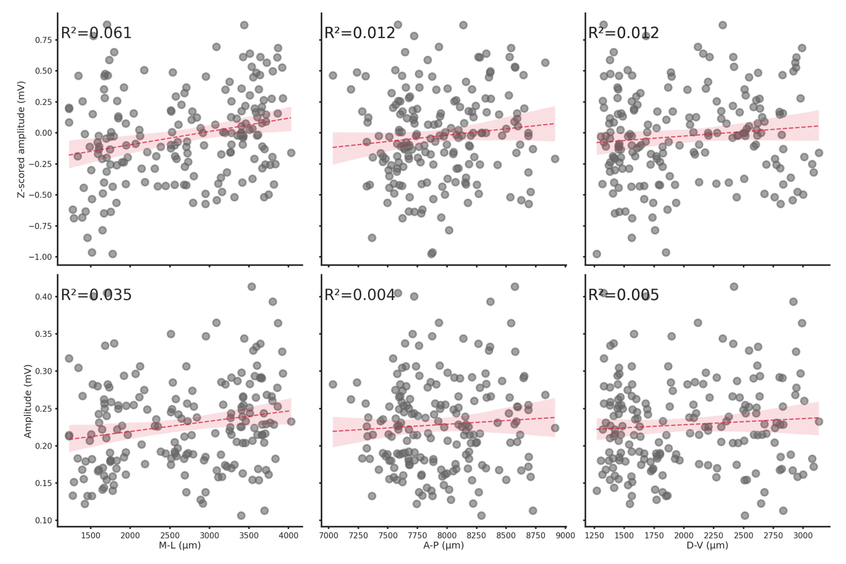

**Supplementary Figure 7. Spatial location does not influence ripple amplitude.**

Relationship between z-scored amplitude (top row) or amplitude (bottom row) and each spatial axis (m-l, a-p or d-v). Spatial location has a negligible effect on ripple amplitude.

**Supplementary Figure 8. Putative excitatory and inhibitory neurons show similiar spiking patterns in lateral and medial ripples.**

Grand average of the differences between medial and lateral ripples induced spiking activity in putative excitatory (a) and inhibitory neurons (b).

**Supplementary Figure 9. Spiking rate and fraction of active neurons are significantly higher in medial ripples**

(a) Fraction of active neurons per ripple grouped by ripple seed location. (Medial seed=40.0±1.0%, lateral seed=39.0±1.0%, p-value=9.52e-05, Student's t-test). (b) Average spiking rate grouped per ripple grouped by ripple seed location (Medial seed=9.0±0.0%, lateral seed=8.0±0.0%, p-value=5.20e-10, Student's t-test). Asterisks mean p < 0.05, Student's t-test.

**Supplementary Figure 10. Spiking rate and fraction of active neurons are increased in the late phase post-ripple start in medial ripples both in putative excitatory and inhibitory neurons.**

(a) Average spiking rate in early (left) and late (right) phase post-ripple start grouped by ripple seed location and putative neuron identity. Asterisks mean p < 0.05, ANOVA with pairwise Tukey post-hoc test. (b) Fraction of active neurons per ripple in early (left) and late (right) phase post-ripple start grouped by ripple seed location and putative neuron identity. Asterisks mean p < 0.05, ANOVA with pairwise Tukey post-hoc test.

**Supplementary Figure 11. Units features in medial and lateral sections**

(a) Kernel density estimate plot of waveform duration (p-value=1.64e-33), firing rate (p-value=6.41e-01), waveform amplitude (p-value=5.48e-01), waveform repolarization slope (p-value=4.09e-01), waveform recovery slope (p-value=1.13e-10) and waveform peak-through ratio (p-value=5.42e-05) grouped by hippocampal section.Asterisks mean p<0.05, Mann-Whitney u test. (b) Cumulative distribution plot of waveform duration (p-value=0.00e+00), firing rate (p-value=9.26e-03), waveform amplitude (p-value=9.09e-02), waveform repolarization slope (p-value=6.90e-02), waveform recovery slope (p-value=1.58e-10) and waveform peak-through ratio (p-value=2.27e-05) grouped by hippocampal section.Asterisks mean p < 0.05, Kolgomorov-Smirnov test.